- Enter www.xcelhr.com in your web browser

- Click on Employee and the Employee Level Login screen will display.

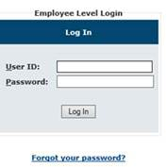

3. Enter your Login/User ID (case sensitive) XPD + your Employee ID (ie. XDPxxxxxxx).

4. Enter your password.

5. Click the Log In button.

6. Choose My Payroll from the menu options.

7. Choose Check History to view all pay stubs.
